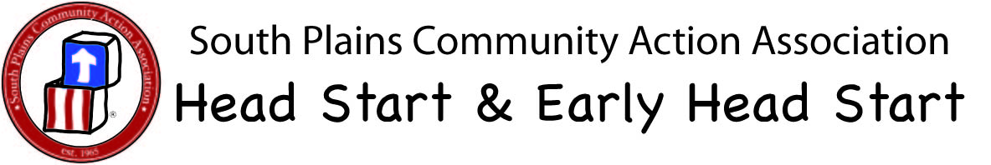

Policy Title: | Medication Administration | Revision Date: | 7/18/17
Contact Person: | Health Staff | PC Approval Date: | 8/12/17
Area: | Health | SPCAA Board Committee Approval Date: | 8/15/17
Stakeholders: | All SPCAA Staff | SPCAA Board Approval Date:
References: | 1302.47(7)iv; MS 746.3801; 746.3803, 746.3805, 746.3803; 746.3805; 746.3807; 746.3809; 746.3811; | Advisory Approval Date:
Related Documents:

Performance Objective: SPCAA Head Start/ Early Head Start allows dispensing of medication at the center only if the doctor specifically, the time the child would be in the Head Start/ Early Head Start classroom, which include any medications given orally, intranasal, ear/eye drops, or topically. Head Start prefers that a child’s medication be dispensed at home (so parents can see if child has a reaction to it). If your child is receiving special types of treatment that must be done at school, the staff will need to be trained on the special equipment or technique required prior to staff administering treatment. Until the training is conducted for the staff, we require that the parents or other authorized person designated by the parent give the treatment.

Procedures:

- In order for staff to administer prescription or non-prescription medication to any child, the staff must have written permission, with parent’s signatures on the Authorization for Dispensing Medication Form. All doses of medication will be documented and will include who administered the medication, time, date, dose, and signature of parents and staff.

- All medication must be in its original container, with a child-proof lid, and to include. prescription label with child’s name. Over the counter medications must have a doctor’s order (including diaper rash medication and/or sunscreen).

- Staff will follow specific doctors’ orders about how the medicine should be given. If staff administering medication is unclear of the instructions, they will call the physician, pharmacist, or parents to clarity information before administering medication. Staff must wash their hands before and after administering any medication.

- No medication will be administrated to children after the expiration date, expired medication will be returned to the parent. All medications will be kept out of children’s reach in a locked container. Non-refrigerated medication can be kept in the filing cabinet under lock and key. Staff must check diaper bag, back pack, etc. for medications. When a child withdraws, medication will be returned to the parent.

5. Staff will be trained in medication administration by HS/EHS nurse in regards to medications given orally, intranasal, ear/eye drops, or topically. Staff will also be trained in the Five Rights of Medication Administration as well as how to read prescription labels. Depending on the child’s illness, a physician or nurse may be asked to describe/demonstrate the specific procedure to be used in treatment.

- An incident report form will be filled out for any medication incidents to include the following: wrong child, wrong medication, wrong dose, wrong time, wrong route or child refusal, spits out dose, vomited dose and any spilled medication. Parent and nurse will be notified. Form will be signed and dated by Site manager.

- In the event child were to have a side effect or reaction, an emergency plan may be needed and/or initiated. Side effects or any reactions will be noted on medication administration form. Staff watch for signs of an allergic reaction (swelling, rash, or breathing difficulties). IF symptoms are noted at any time parents is notified, it is documented, as well as activation of emergency response system depending on severity.

- Parents should communicate with HS/EHS staff regarding and changes in treatment with medications. Staff will communicate with parents regarding any medications that are damaged so replacement can be obtained.

- Monitoring will be done in the fall, spring and Local Self-Assessment (LSA) to include follow-up. Additional monitoring will be done as needed.

- Poison Control Center 1-800-222-1222

For help needed have the following information readily available:
  - Medication Container
  - Medication Log
  - Child’s Health Assessment Form
  - Child’s Current Weight

Monitoring

Monitoring is done in the Fall, Spring and Local Self-Assessment (LSA)/Think Tank to include follow-up. Additional monitoring is done as needed

