SPCAA Head Start/Early Head Start Program Policy & procedure
Health & Safety
Approve by Health Advisory on 9/24/08 Approved by the Policy Council 4/18/09 Approved by Board _4/16/09__

Subject: Short-Term Exclusion and Admittance

Reference Source: Performance Standards 1304.22 (b) 1, 2 and
TDFPS Child Care Licensing Standards 746.3601, 3603, 3605 and 3607.
Texas Department of Health, 25TAC 97.7

Supporting Information: Attachment V - Communicable Disease Chart for Schools and Child Care Centers provided by TDFPS, Child Care Licensing

Policy:

Head Start and Early Head Start will lower the risk of spreading communicable disease in our classrooms and offices through preventive health practices and appropriate procedures, including training, supplies and practicing universal precautions. The program will be responsible and follow the generally accepted practices related to public health issues. This policy applies to all persons – children, staff and volunteers. Parents are encouraged to seek necessary medical treatment or assistance as soon as possible to help children bounce back to good health. Reducing the days of illness or absence helps children continue with optimal growth and development.

SPCAA and its partners are not licensed to provide get-well care and therefore cannot admit an ill child for care if one or more of the following exists:

- The illness prevents the child from participating comfortably in child-care center activities including outdoor play;

- The illness results in a greater need for care than caregivers can provide without compromising the health, safety, and supervision of the other children in care;

- The child has one of the following, unless medical evaluation by a health-care professional indicates that you can include the child in the child- care center's activities:

  - Oral temperature of 100.4 degrees or greater, accompanied by behavior changes or other signs or symptoms of illness;

  - Rectal temperature of 101.4 degrees or greater, accompanied by behavior changes or other signs or symptoms of illness;

  - Armpit temperature of 99.4 degrees or greater, accompanied by behavior changes or other signs or symptoms of illness; or

  - Symptoms and signs of possible severe illness such as lethargy, abnormal breathing, uncontrolled diarrhea, two or more vomiting episodes in 24 hours, rash with fever, mouth sores with drooling, behavior changes, or other signs that the child may be severely ill; or

- A health-care professional has diagnosed the child with a communicable disease, and the child does not have medical documentation to indicate that the child is no longer contagious.

Per state licensing requirements, specific communicable diseases exclude a child from attending the center. They reference Subchapter R, Health Practices Division 3, Illness and Injury and lists of communicable diseases that exclude a child from care, including a get-well care program, are defined by the Texas Department of Health (TDH) in 25 TAC §97.7 (relating to Diseases Requiring Exclusion from Child-Care Facilities and Schools). These can be accessed this information from the Texas Department of Health or Licensing staff.

Also attached to this policy is Attachment V from the Texas Child Care Licensing Standards which provides guidance on signs and symptoms, incubation periods, exclusion from attendance, readmission criteria, if the disease is reportable, and notes for prevention and treatment.

The Texas Department of Health (department) publication titled "Recommendations for the Prevention and Control of Communicable Diseases in a Group-Care Setting" may be used to determine the incubation period, early signs of illness, and prevention/treatment measures of communicable conditions. Copies are available from the Infectious Disease Epidemiology and Surveillance Division, Texas Department of Health, 1100 West 49th Street, Austin, Texas 78756 upon request.

SPCAA as the owner or operator of child-care licensed facilities, or its partners as school administrator or operators of child care facilities shall exclude from attendance any child having or suspected of having a communicable condition.

Parent will be provided a Fact Sheet on illness child is experiencing as part of health and preventive education.

If a child is sent home (excluded) from the center, the child will not be able to return to the center until 24 hours after close of business on the day the child is sent home, and is symptom free. When the child returns to the center, the daily

health check must be completed, in the presence of the parent, to make sure child is symptom free and able to participate in the daily activities.

Example of child who is ill:
Child vomited at 8:30 am on Monday, September 22, 2008 and again at 8:45am.
Mother was called at 9:50 am to pick up the child. As stated on Short Term Exclusion Policy a child my return to school 24 hours after close of business which is 5:30 p.m. Child may return on Wednesday, September 25, 2008 at 7:30 a.m.

If the child has a fever, the child cannot return to the classroom until they have 8 (eight) hours without a fever reducer (medication) to maintain a normal temperature.

Example of child who is ill and has fever:

Monday, October 6, 2008 - Child came to school and teacher noticed the child was hardly eating breakfast and was not as talkative. Teacher took temperature at 9:00 am – temperature 102.3 and again at 9:30 am and it was
  - Parent was called at 9:35 am. As stated on Short Term Exclusion Policy a child my return to school 24 hours after close of business which is 5:30 p.m. Child would be allowed to return on Wednesday, October 8, 2008 at 8:00 am.

When the child returned to school on Wednesday, October 8, 2008 at 8:00am, parent stated the child had a taken Tylenol at 7:30pm on Tuesday, October 7, 2008 for a temperature of 101. The child must be free of fever for 8 hours without using any medication to reduce temperature therefore child could not stay at the center but could return 8:00 am on Thursday, October 9, 2008.

Exclusion shall continue until the readmission criteria for the conditions are met. The conditions and readmission criteria are as follows:

    - amebiasis--exclude until treatment is initiated;

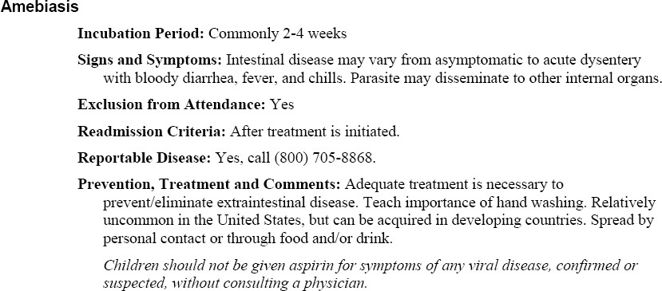

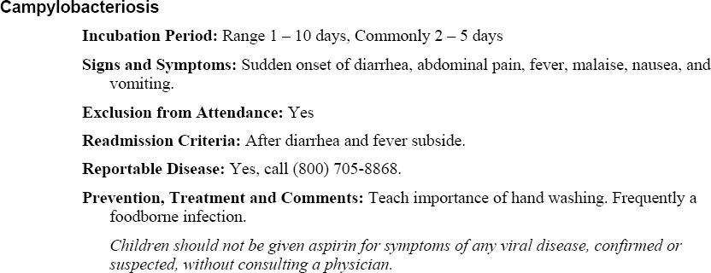
    - campylobacteriosis--exclude until after diarrhea and fever subside;
    - chickenpox--exclude until after seven days from onset of rash, except immunocompromised individuals who should not return until all blisters have crusted over (may be longer than seven days);
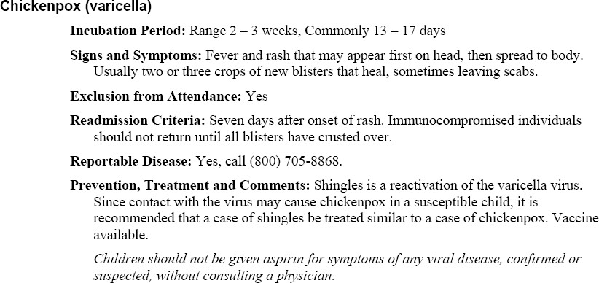
    - common cold--exclude until fever subsides;

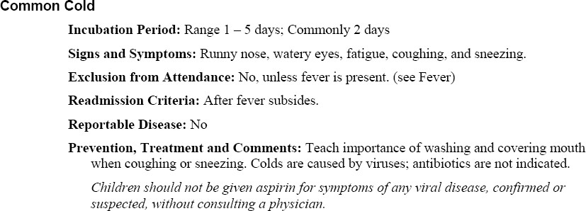

    - conjunctivitis, bacterial and/or viral--exclude until written permission and/or permit is issued by a physician or local health authority;
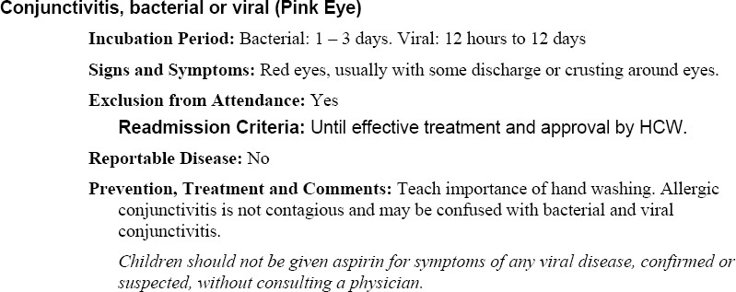
    - fever--exclude until fever subsides;
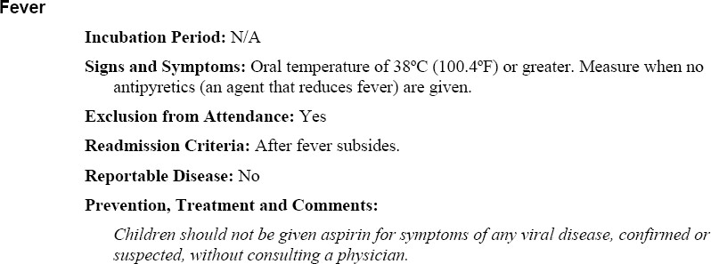

    - fifth disease (erythema infectiosum)--exclude until fever subsides;

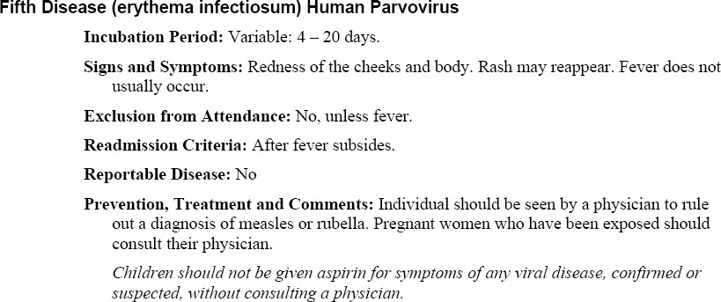

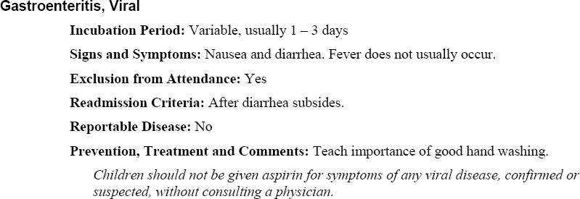
    - gastroenteritis, viral--exclude until diarrhea subsides;
    - giardiasis--exclude until diarrhea subsides;
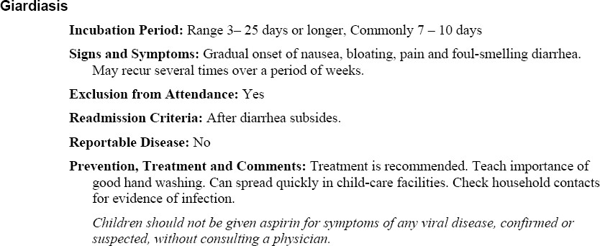
    - head lice (pediculosis)—As per Health Advisory children will be lice and nit free and be exclude until one medicated shampoo or lotion treatment has been given;

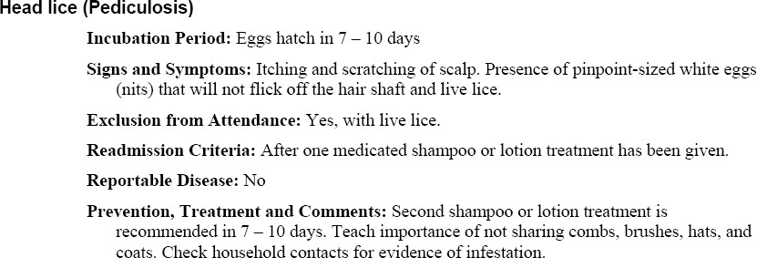
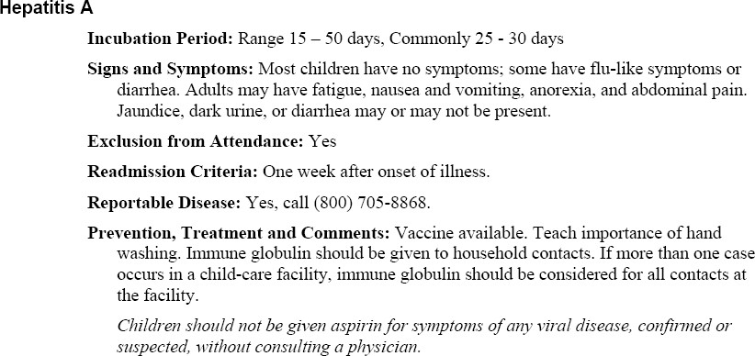
    - hepatitis, viral, Type A--exclude until one week after onset of illness;

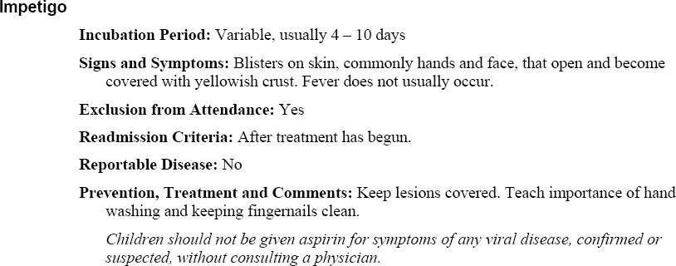
    - impetigo--exclude until treatment has begun;
    - infectious mononucleosis--exclude until physician decides or fever subsides;

    - influenza--exclude until fever subsides;

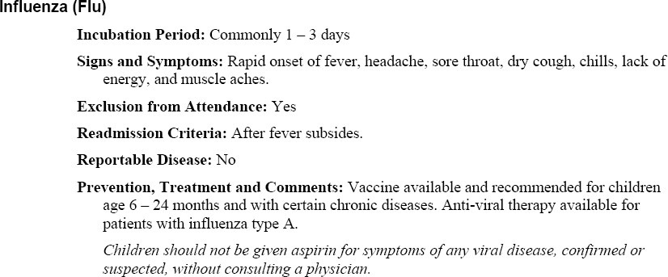
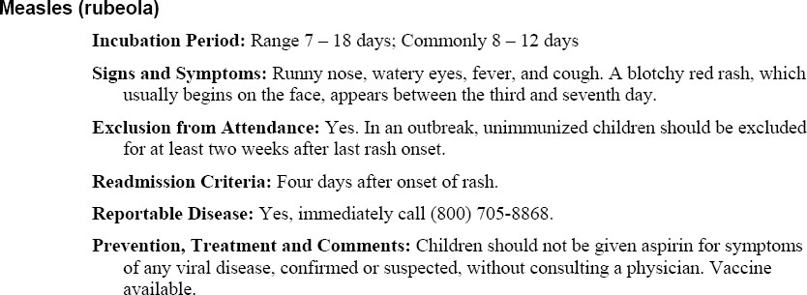
    - measles (rubeola)--exclude until four days after rash onset or in the case of an outbreak, unimmunized children should also be excluded for at least two weeks after last rash onset occurs;
    - meningitis, bacterial--exclude until written permission and/or permit is issued by a physician or local health authority;
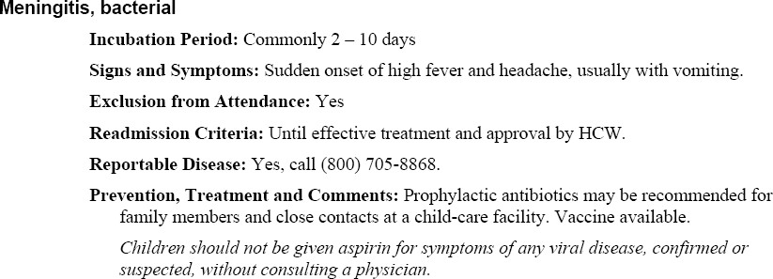
    - meningitis, viral--exclude until fever subsides;

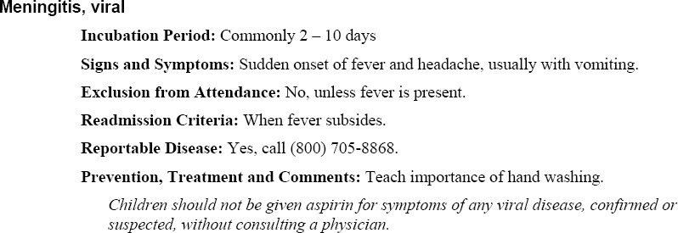
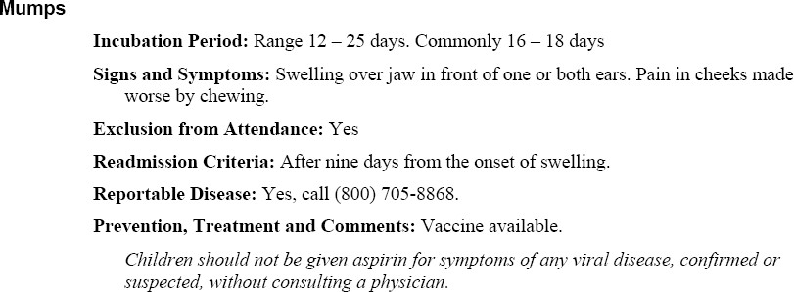
    - mumps--exclude until nine days after the onset of swelling;
    - pertussis (whooping cough)--exclude until completion of five days of antibiotic therapy;
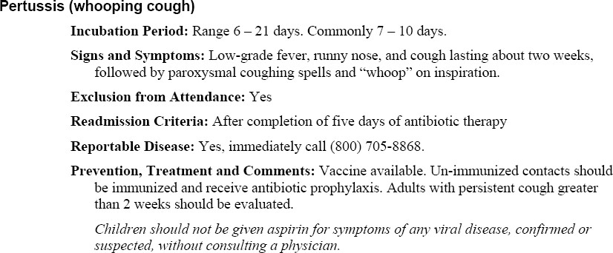
    - ringworms—includes all types as outlined in the Communicable Disease Chart for Schools & Child Care Centers.

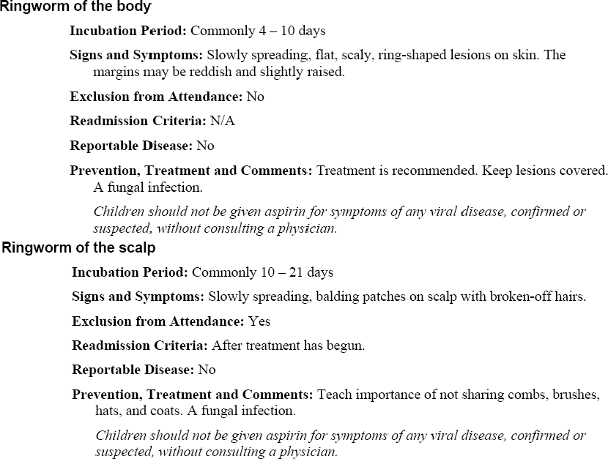
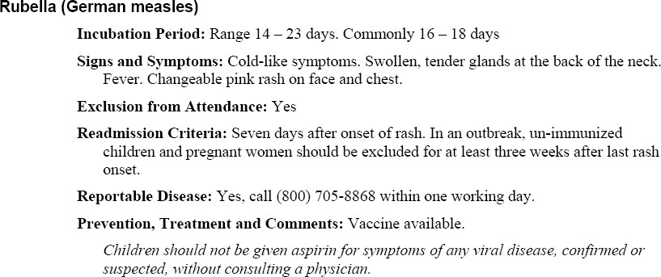
    - rubella (German measles)--exclude until seven days after rash onset or in the case of an outbreak, unimmunized children should be excluded for at least three weeks after last rash onset occurs;
    - salmonellosis--exclude until diarrhea and fever subside;

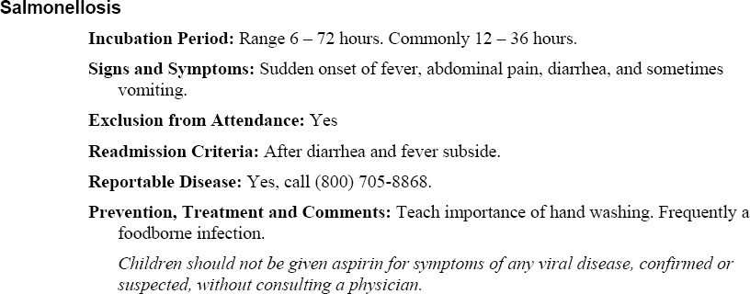
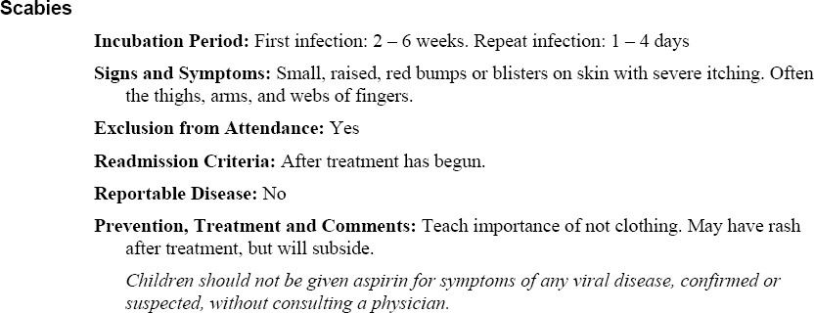
    - scabies--exclude until treatment has begun;
    - shigellosis--exclude until diarrhea and fever subside;
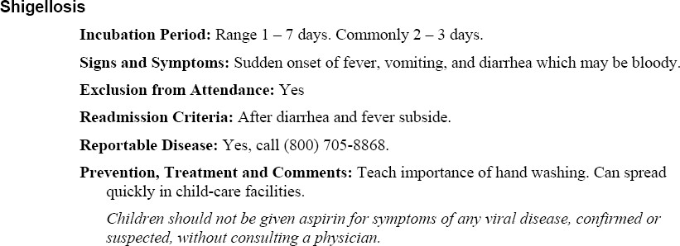
    - streptococcal sore throat and scarlet fever--exclude until 24 hours from time antibiotic treatment was begun and fever subsided; and

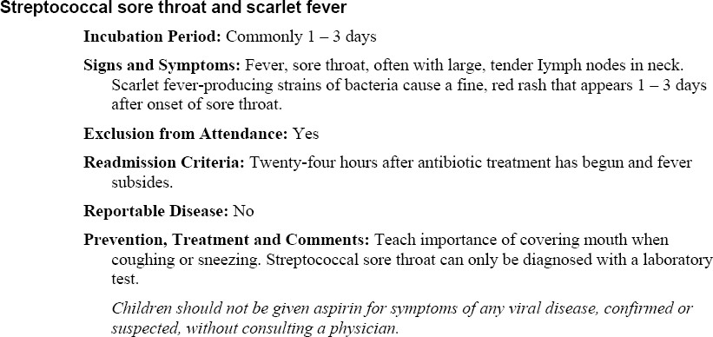

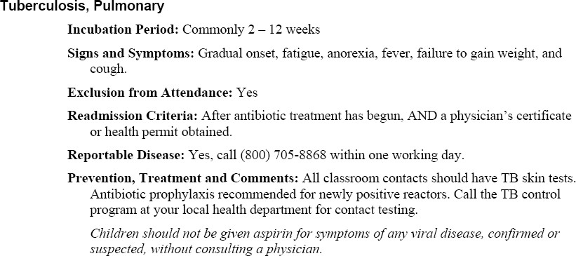
    - tuberculosis, pulmonary--exclude until antibiotic treatment has begun and a physician's certificate or health permit obtained.

- Further by state law, owners or operators of a child-care facility, or the school administrator, such as SPCAA or it’s partners shall exclude from attendance any child having or suspected of having a communicable disease designated by the commissioner of health (commissioner) as cause for exclusion until one of the criteria listed in subsection (d) of this section is fulfilled.

- Any child excluded for reason of communicable disease may be readmitted, as determined by the health authority, by submitting:
  - a certificate of the attending physician, advanced practice nurse, or physician assistant attesting that the child does not currently have signs or

symptoms of a communicable disease or to the disease's non- communicability in a child-care or school setting;
  - a permit for readmission issued by a local health authority; or
  - readmission criteria as established by the commissioner.

(e.) Notifications

- The Center Director should be alerted if any person (child, staff or volunteer) is suspected of having a communicable/infectious disease.. (See list of communicable and infectious diseases are listed above. )

- The Center Director (CD) will notify the child’s parent immediately after a child has signs or symptoms that indicates s/he may have an illness requiring exclusion from the center. Parent (s) or emergency contacts should pick up the child if she/he appears to have symptoms of a communicable disease or becomes ill at school.

Center staff will utilize the child exclusion guidance provided in section (a) above. When necessary the Health Manager will be contacted for assistance to insure the processes and policies are followed. Based on the individual circumstances, the Health Manager will make further inquiries to health professionals as needed.

The expectation is that the parent or emergency contact will pick up the child and provide appropriate medical treatment for the child and that the child will not return to the center until the condition is no longer contagious.

Procedure for Caring for a Sick Child While Waiting for the Parents to come to the Center.

  - Isolate child from the other children in a way that is nurturing to child and as much as classroom/office space allows.
  - When needed provide the child with a resting mat to lay on while they are waiting. (the mat needs to be labeled for ―sick Child‖)
  - Mat used for child resting and toys played with while waiting for parent to arrive must be sanitized following use.
  - Take child’s temperature when any of the following signs are present:
Nausea, vomiting, flushed cheeks, warm to the touch on the back of your hand, diarrhea, excessive coughing, or fatigue
  - Turn the digital thermometer on, the power button is on the end or near area displaying temperature.
  - Place a thermometer probe cover over the portion of thermometer that will be placed in the child’s mouth.

  - Have child hold it under their tongue until the temperature is displayed (typically this is less than two minutes, sometimes within 30 seconds). The child may need help holding the thermometer still in her/his mouth. A normal temperature is
98.6 degrees F. A temperature of 100.4 warrants a call to the parent or guardian to let them know that their child is sick and they need to come pick them up as soon as possible.

  - Each site has a 2nd. Digital thermometer to be used as a back up thermometer.

- Based on the guidance from child care licensing and the Center for Disease Control (CDC), the Center Director is required to notify others of specific illnesses.

If required, the Center Director (CD) will notify other parents with the following
processes:

  - If the Center Director becomes aware that a child in care, staff or volunteer has contracted a communicable disease that requires a report to the Texas Department of Health, the Center Director will provide a written notice to all parents of children in the center within 48 hours or less. The notice will contain information about the illness and individual identity will be treated as confidential.

  - When there is an outbreak of lice or other infestation in the group, the Center Director will notify the parents immediately (best practice). By either posting a dated written notice in the center in a prominent and publicly accessible place or sending an individual note to each parent. Child Care Licensing (746.307) gives up to 48 hours for parents to be notify.

5. Documentation will occur on the attendance report for children who are sent home because they are not feeling well and/or suspected of having a communicable disease or infestation.

Procedures for Staff, Volunteers or Other Adults

Staff, volunteers or other adults must not come to work when they are ill. If a staff member has any of the signs or symptoms described in the child exclusion guidelines, they are to report this to the Center Director or their immediate supervisor.

The Center Director or Supervisor will be contacted to ensure that the sick staff person is sent/stays home and another staff person is designed to preform their duties. When necessary, a substitute or other Head Start employee or volunteer will be contacted to cover for classroom or center staff who is ill.

The program will follow guidance established by the Center for Disease Control and other applicable regulations with regard to re-admitting an employee to work with children.

