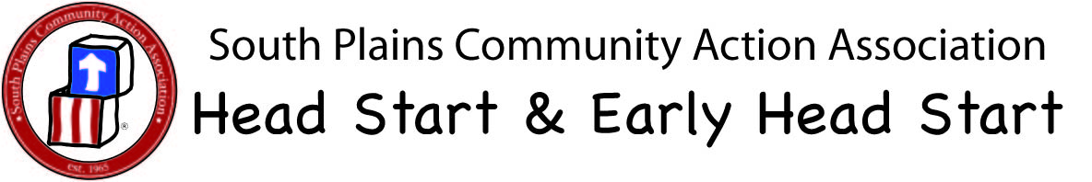

Early Head Start

Wrong amount of toothpaste Correct amount of toothpaste
for Early Head Start Children. for Early Head Start children.
Use a small smear of
toothpaste.

