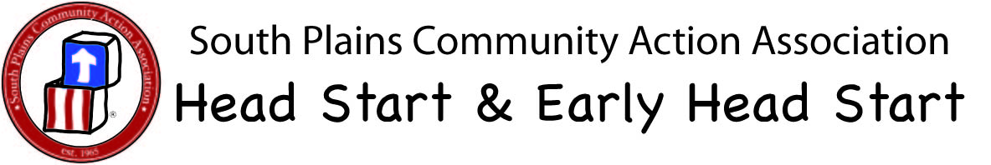

FIRST AID FOR ASTHMA

Severe Symptoms May Include:

Difficulty Speaking | Fearful
Wheeze, cough or shortness of breath | Difficulty Walking and Talking

Lips or fingernails are blue or gray colored

Neck and chest are “sucked in” with each breath

Child has any of the above symptoms and NO rescue medication is available call 911 Immediately! If child has rescue medications available, follow steps below.
1
STAY CALM, SPEAK REASSURINGLY & PROVIDE PRIVACY

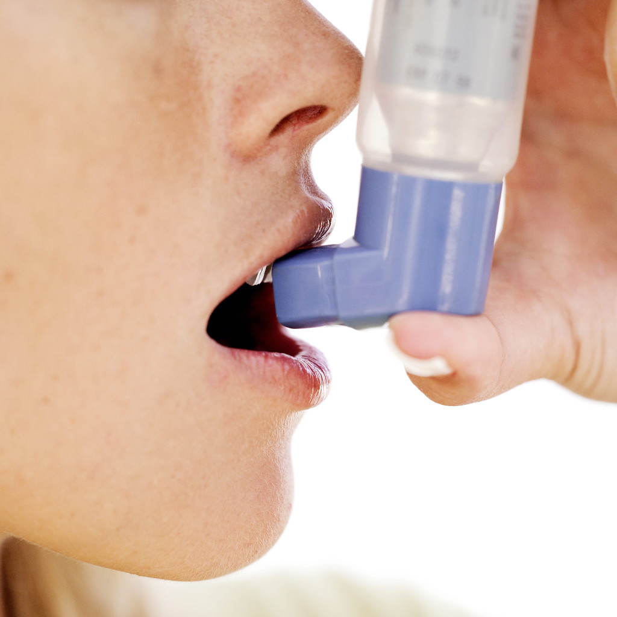

2

STOP ACTIVITY AND HELP CHILD SIT UPRIGHT, RELAX SHOULDERS &

DO NOT RECLINE
3
FOLLOW INDIVIDUALIZED HEALTH PLAN AND HAVE ADULT REMAIN WITH CHILD
5
IF CHILD IS STILL HAVING TROUBLE BREATHING 5 – 10 MINUTES AFTER TAKING RESCUE MEDICATION, RE-ADMINISTER THE MEDICATION AS DIRECTED IN THE CHILD’S INDIVIDUALIZED HEALTH PLAN. IF NO RELIEF 15-20 MINUTES AFTER 2ND DOSE, CALL 9-1-1. IF CHILD HAS FREQUENT ASTHMA ATTACKS, PARENT NEEDS TO CONTACT PROVIDER TO SEE IF MEDICATION CHANGES MIGHT BE NEEDED.

6
CALL 9-1-1 IF THERE IS NO RELIEF AFTER RE-ADMINSTRATION OF MEDICATION
NOTIFY PARENT AS PER PLAN.
4

