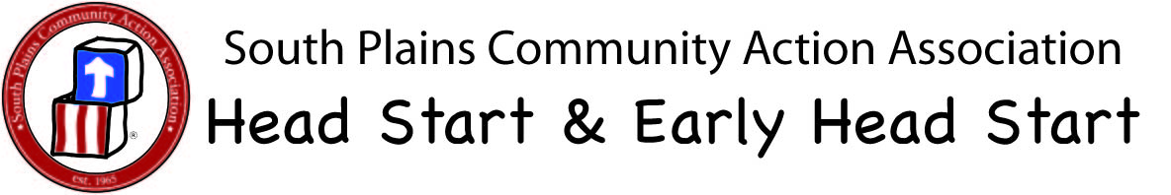
Head Start/Early Head Start
Health Check
Site & Classroom: ___________________________________ Date: _________________
Child’s Name | Crying/Happy | Severe Coughing | Rash/Diaper Check | Swelling or Bruises | Discharge from Eyes, Nose, Ears | Sores/Cuts/Scrapes | Comments
Y-YES N-NO C-CRYING H-HAPPY

