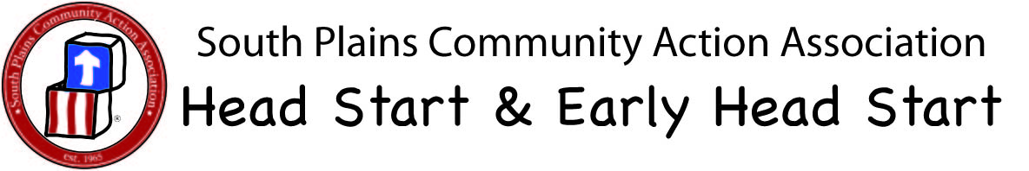
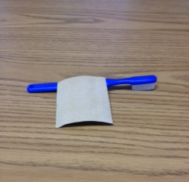
Steps to Labeling Toothbrushes and Toothbrush Holders for Licensed EHS Sites and/or EHS Grantee Sites
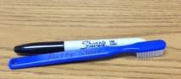
- Sand back of tooth brush with sand paper.

- Write child’s 1st and last name on back of toothbrush using a permanent maker.
(do not use tape on the toothbrush)

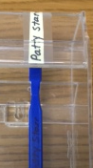
- Label toothbrush holder using child’s 1st and last name (using paper and tape)
And/or child’s picture.

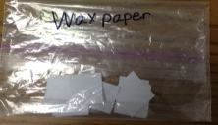

- Cut wax paper into small one inch square to dispense
small smear of toothpaste on and place in a baggie.
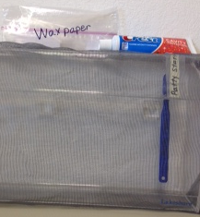

- Place wax paper baggie and toothpaste on top of the toothbrush holder.

