
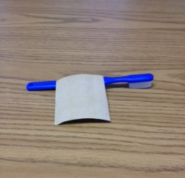
Steps to Labeling Toothbrushes and Toothbrush Holders for Partner Sites
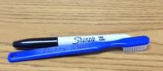
- Sand back of tooth brush with sand paper.

- Write child’s 1st name and initial of last name on back of toothbrush using a
permanent maker. For children with the same name a symbol can be used to
Identify child (do not use tape on the toothbrush)
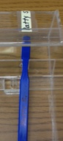

- Label toothbrush holder using child’s 1st name and initial of last name
(using paper and tape) and/or child’s picture.

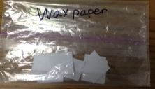

- Cut wax paper into small one inch square to dispense
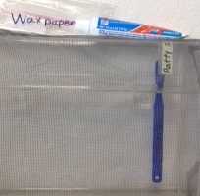
small pea sized toothpaste on and place in a baggie.

- Place wax paper baggie and toothpaste on top of the toothbrush holder.

