Entering ASQ:SE and Articulation Rescreens in ChildPlus

- Go to the Health Tab.
- Highlight the ASQ:SE or Articulation Event that was rescreened.
- Scroll down to 2.Actions Associated with this ASQ:SE/Articulation
- Click “Add Action.”
- Set Action Type to Evaluation
- Scheduled Date- Enter date of rescreen
- Action Date- Enter date of rescreen. (Should match Scheduled Date)
- Description-Enter either ASQ:SE Rescreen or Articulation Rescreen
- Status- Select Pass if rescreen was passed or Obtain Additional Information if it was not passed
- Agency Worker- Name of staff entering referral
- Provider- Select HS/EHS Staff
- Provider Type- Select Head Start Staff
- Funding- Select Free - No Cost
- Click on the time stamp button and enter the Action Notes. Include:
- the form that was used (age and language)
- the results of the rescreen (passed, didn’t pass- Remember, we don’t say they “failed”)
b) any concerns
c) any action needed (referral to MH/D, etc.)
15. IMPORTANT: Scroll back up to the original event and uncheck any boxes that are checked beneath the “Results” section of the original screening.

Entering ASQ:SE and Articulation Rescreens in ChildPlus

1
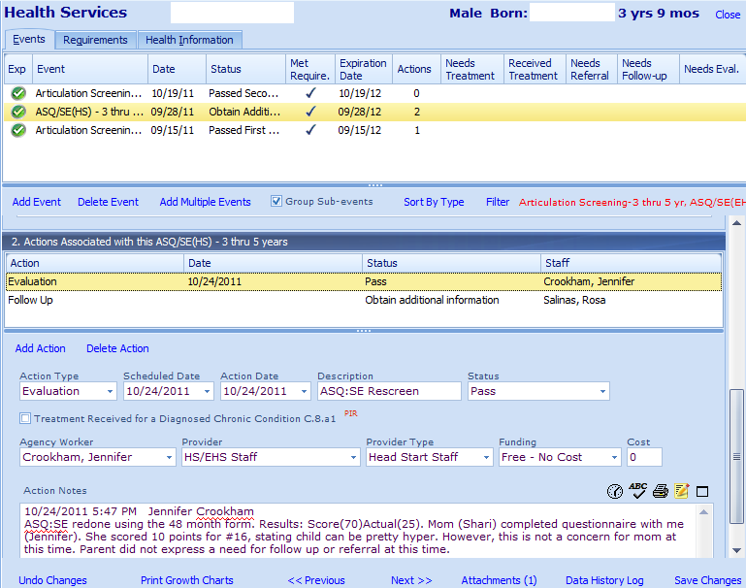
13
12
11
10
9
8
7
6
5
4
3
14
2

