Articulation Screening- 3 through 5 Years

Under the HEALTH tab of ChildPlus
- Click on Add Event. The event type is Articulation Screening- 3 thru 5 years. Click OK.
- Enter Scheduled Date- date completed
- Enter Event Date (Event and Scheduled date will be the same)
- Expiration Date- one year from event date (automatically pops up)
- Status- Passed First Screening (if child met pass criteria… If PLS-4 was used, Summary section should have “Pass” checked for all sections.)
Obtain Additional Information (if score does not meet pass criteria)
- Description- PLS-4 Articulation Screening
- Results- Referral Needed (if any item is marked Obtain Additional Information) or
No Referral Needed (if all items are marked Pass)
- Medical Health Needs- Do not check any of these items for the Articulation Screening!
- Agency Worker- Name of person entering the information
- Provider- Use drop down arrow and click on the appropriate provider who completed the event (Public School Provider or HS/EHS Staff)
- Provider Type- Use drop down arrow and click on the appropriate provider who completed event (Public School Provider or HS/EHS Staff)
- Funding- Free - No Cost
- Notes- Click the clock and add notes. In this section, enter which Record form was used (age 3, 4, or 5) and any other information to consider further assessment or outcomes (i.e., child was sleepy, completed in Spanish)
- Click on Save Changes
Partner Sites:
- If entering articulation completed before the child was enrolled in Head Start (i.e., while child was a Pre-K child), enter as above EXCEPT for the Scheduled and Event dates. Use child’s Head Start enrollment date as the Scheduled and Event dates and document actual date screened in Notes so we know why the date in Child Plus doesn’t match what’s in the folder.

*If using the ARD/IEP to satisfy the Articulation Screening requirement, see steps on page 2.*

Inputting Child’s ARD/IEP as the Articulation Screening Requirement

***Use These Steps ONLY for Child Currently in Speech Services who have Current ARD/IEP papers in the Brown Folder. Contact Mental Health & Disabilities staff if you aren’t sure.***

Under the HEALTH tab of ChildPlus
- Click on Add Event. The event type is Articulation Screening- 3 thru 5 years. Click OK.
- Enter Scheduled Date- Child’s enrollment date
- Enter Event Date (Event and Scheduled date will be the same)
- Expiration Date- one year from event date (automatically pops up)
- Status- In Treatment Process
- Description- Current ARD/IEP
- Results- In Treatment Process
- Medical Health Needs- Do not check any of these items for the Articulation Screening!
- Agency Worker- Name of person entering the information
- Provider- Use drop down arrow and click on the appropriate provider who completed the event (Public School Provider or HS/EHS Staff)
- Provider Type- Use drop down arrow and click on the appropriate provider who completed event (Public School Provider or HS/EHS Staff)
- Funding- Free - No Cost
- Notes- Click the clock and add notes. In this section, enter which “Child is currently in treatment and has a current IEP dated _______ to ________” (Dates can be found on the IEP in child’s folder)
- Click on Save Changes

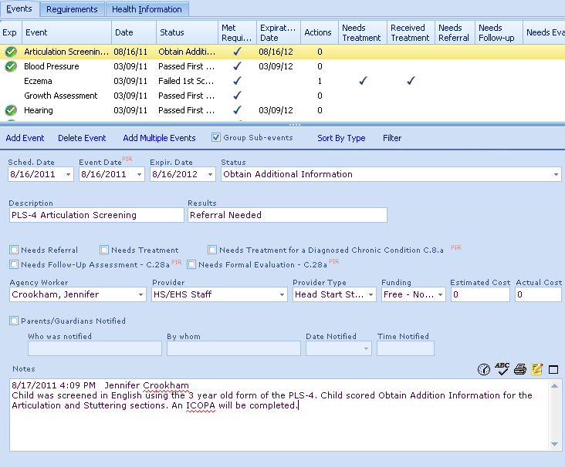
13
12
111
9
10
8
7
6
5
4
3
1
2

