Documenting Plans of Action (POAs) for Mental Health/Disabilities in ChildPlus
(Articulations, ASQ:SEs, MHD concerns- parents/recruitment, and MHD concerns- physical)

NOTE: Classroom behavior concerns and POAs will be documented elsewhere.

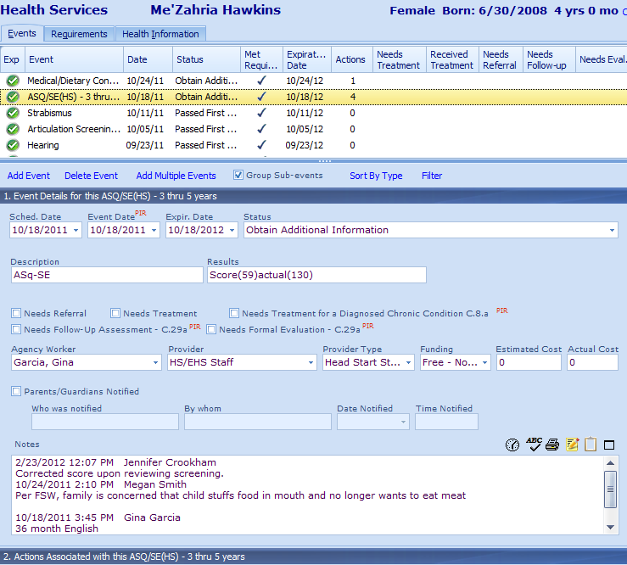
2
1
3

1. Under the Health tab, select the ASQ:SE, articulation, or MHD concern event.
2. Scroll down to where you can see section 2.

Putting ICOPAs for ASQ:SEs and Articulations in Child Plus (Continued)

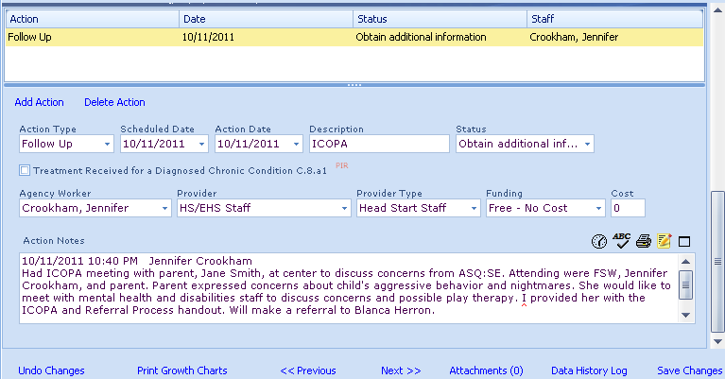
3
14
13
12
11
10
9
4
5
6
7
8

3. Click on “Add Action”
4. Under Action Type, select “Follow Up”
5. Enter the Scheduled Date. This is typically the date of the POA, unless you had to reschedule.
6. Enter the Action Date- the date the POA was completed.
7. Enter “POA” as the Description.
8. Enter the Status. There are 3 options for the Status:
a) If team decides to rescreen or refer, Status will be “Obtain Additional Information”
b) If parent declines rescreening and/or referral, Status will be ”Parent Refused Treatment”
c) If child is already in services for the concerns noted on this questionnaire and parent does not want any additional referral or evaluation, Status will be “In Treatment Process”
9. Put your name under Agency Worker.
10. Select “HS/EHS Staff” for Provider.
11. Select “Head Start Staff” for Provider Type.
12. Select “Free-NoCost” under Funding.
13. Click on the time clock button and enter your notes. Include all of the following:
a) the people attending the POA meeting
b) the concerns that were discussed
c) the plan of action (i.e., refer, rescreen, declined services, or already in services).
14. Click “Save Changes”
15. IMPORTANT: Scroll back up to the original event and uncheck any of the boxes that are checked.

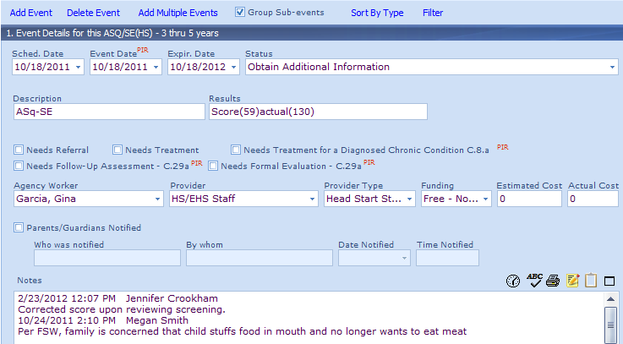
15. These should never be checked!

16. Copy your POA note to a new contact note under Family Services with the Event Type set as “ICOPA Contact”. Print your contact note and file it under Flap 3 with the POA.

