Documenting Mental Health & Disabilities Referrals in Child Plus
For ASQ:SEs/Articulations/MHD Concerns
HEALTH Tab
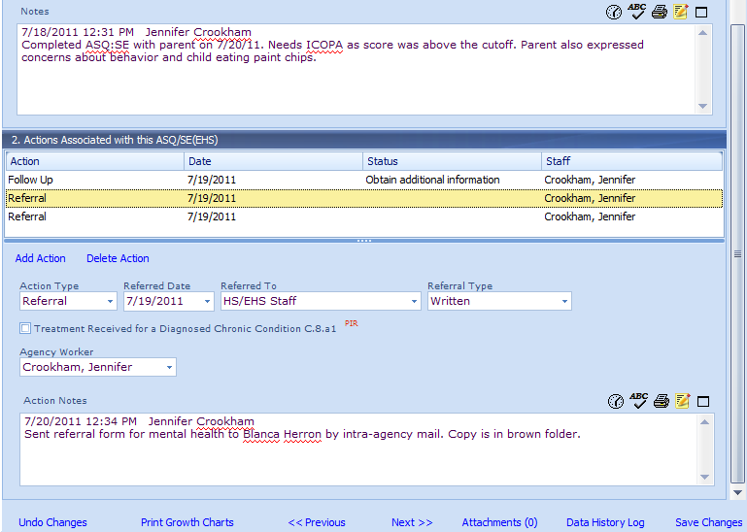
10
9
8
7
5
6
4
3
2
- Under the Health tab, select the ASQ:SE, Articulation, or MHD Concerns event needing a referral.
- Scroll down to Section 2 under the selected ASQ:SE or Articulation.
- Click on “Add Action.”
- Action Type- selected “Referral”
- Referred Date- Enter date referral was made.
- Referred to- Enter who you referred to (i.e., HS/EHS Staff).
- Referral Type- Indicate whether the referral was Written or Verbal. If referring to ECI (EHS) and/or MH/Disabilities staff, this should always be “Written.”
- Agency Worker- Name of staff entering referral
- Click on the time stamp and enter your Action Notes, including
  - who you sent the referral to
  - how you sent it (e-mail, inter-office mail)
  - when you sent it
- Click on “Save Changes”
- IMPORTANT: Scroll back up to the original event and uncheck any boxes that are checked.
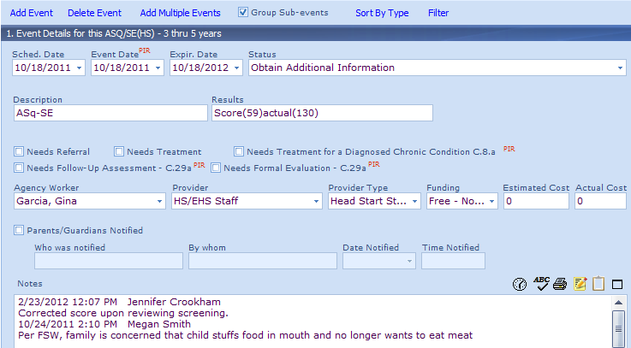
11. These should never be checked!

