Ages and Stages Questionnaire: Social-Emotional (ASQ:SE)

Under the HEALTH tab of ChildPlus
- Click on Add Event. The event type is ASQ:SE(HS)-3 thru 5 or ASQ:SE(EHS). Click OK.
- Enter in Scheduled Date- date completed
- Enter Event Date (Event and Scheduled date will be the same)
- Expiration Date- one year from event date (automatically pops up)
- Status- Passed First Screening (if child’s score was EQUAL to or BELOW the cutoff score AND there were no concern bubbles or parent concerns)
Obtain Additional Information (if child’s score fell ABOVE the cutoff score or parent expressed concerns)
- Description- ASQ:SE
- Results- No Referral Needed (if status was passing)
Referral Needed (if child’s score was not passing or parent expressed concerns)
- Medical Health Needs- Do not check any of these items for the ASQ:SE Screening!
- Agency Worker- Name of person entering the information
- Provider- Use drop down arrow and click on the appropriate provider who completed the event (HS/EHS Staff)
- Provider Type- Use drop down arrow and click on the appropriate provider who completed event (HS/EHS Staff)
- Funding- Free - No Cost
- Notes- Click the clock and add notes. In this section, enter which form was used (24 month English form, 36 month Spanish form, etc.) and any concerns voiced or other information to consider further assessment or outcomes (i.e., parent stated she is concerned about child’s eating- referral will be made to dietitian, parent stated she is concerned about child’s behavior and an ICOPA will be completed, etc.)
- Click on Save Changes

Early Head Start
- For children under 3 months, you will need to use the Denver II Screening instead of the ASQ:SE. See page 2 for instruction on inputting the Denver II.

Denver II
Under the HEALTH tab of ChildPlus
- Click on Add Event. The event type is ASQ:SE(EHS). Click OK.
- Enter in Scheduled Date- date completed
- Enter Event Date (Event and Scheduled date will be the same)
- Expiration Date- one year from event date (automatically pops up)
- Status- Passed First Screening (if child met pass criteria for their age)
Obtain Additional Information (if child did not meet pass criteria for age)
- Description- Denver II
- Results- No Referral Needed (If child met pass criteria) or Referral Needed (if child did not meet pass criteria)
- Medical Health Needs- Do not check any of these items for the Denver II Screening!
- Agency Worker- Name of person entering the information
- Provider- Use drop down arrow and click on the appropriate provider who completed the event (HS/EHS Staff)
- Provider Type- Use drop down arrow and click on the appropriate provider who completed event (HS/EHS Staff)
- Funding- Free - No Cost
- Notes- Click the clock and add notes. In this section, enter which form was used (age 3, 4, or 5 and English or Spanish) and any concerns voiced or other information to consider further assessment or outcomes (i.e., parent stated she is concerned about child’s eating- referral will be made to dietitian, parent stated she is concerned about child’s motor skills and an ICOPA will be completed, etc.)
- Click on Save Changes

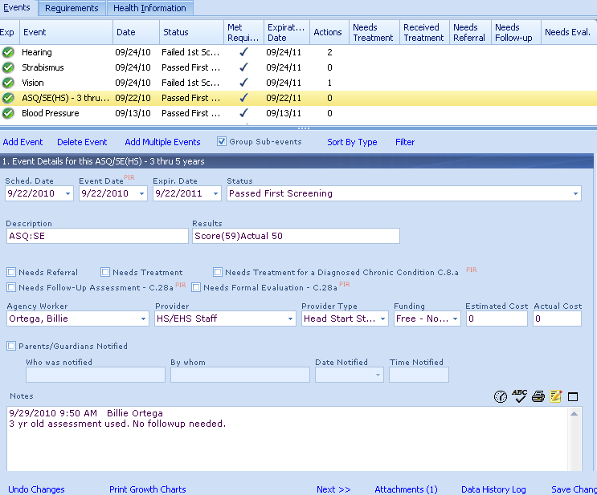
1
2
3
4
5
6
7
8
9
10
11
12
13
14

