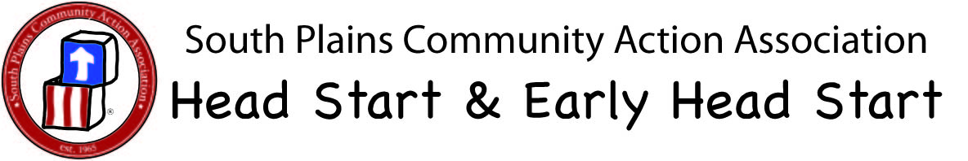

Parliamentary Procedure Cheat Sheet

If You Want To……. | You Say To The Chair…….
Add to or change a motion. (Two times only) | I wish to amend the motion.
Stop a motion You have made | I wish to withdraw the motion. (No vote needed)
Get discussion back on track | I call for the order of the day.
End discussion | I move that we close debate. (Requires 2/3 vote)
Get more information on matter being discussed | Point of information.
Close meeting | I move to adjourn.

Parliamentary Procedure Cheat Sheet

If You Want To……. | You Say To The Chair…….
Add to or change a motion. (Two times only) | I wish to amend the motion.
Stop a motion You have made | I wish to withdraw the motion. (No vote needed)
Get discussion back on track | I call for the order of the day.
End discussion | I move that we close debate. (Requires 2/3 vote)
Get more information on matter being discussed | Point of information.
Close meeting | I move to adjourn.

