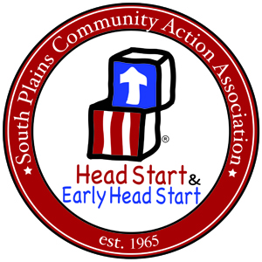
South Plains Community Action Association
Head Start & Early Head Start Division

Parent Committee Meeting Trainings and Parent Activity Day Trainings

Mandatory Topics | Dates and Venue  Trainings Offered | Trainer
Parenting Skills
- Educational and developmental needs
- Activities of Child
- Learning how to share concerns with program staff

Family Literacy
- Increase access to materials, services, and activities essential to family literacy development.
- Support parent’s role as children's first teacher.
- Parent literacy training that leads to economic self-sufficiency and Financial Literacy
Substance Abuse
Child Abuse and Neglect
Domestic Violence
Medical and Dental Education Program
- Assets parents in understanding how to enroll and participate in a system of ongoing health care.
- What is a Medical and Dental Homes and How to get Health Insurance.
- Encourages parents to become active partners in their children's medical and dental health care process and to accompany their child to medical and dental examinations and appointments.
- Emergency First Aid
- Occupational and environmental hazards
- Safety practices for use in the classroom and in the home
- Provides parents with the opportunity to learn the principles of preventive medical and dental health.
- General topics (e.g., maternal and child health and the prevention of Sudden Infant Death Syndrome)
Nutrition Education Program
- Selection and preparation of food to meet families needs
- Management of food budgets

Mental Health Education Program
- What is Mental Health? And How to discuss your families and child's mental health related issues with teachers and other professionals.
Community Advocacy
- How do I make my community more responsive to my needs and interest?
- What resources are available in my community? How to use 211.
Transitions
- Teach Parents to excursive right and responsibilities concerning education of child in school
- Assist parents to communicate with teachers and other school personal.

