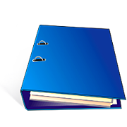
Parent Involvement Notebook (PIN) Checklist

Site Name___________________________________________________

Month_______________________________________________________

- PIN checklist
- Parent committee meeting items
  - Three parent committee meeting notices
    - 1st notice
    - 2nd notice
    - 3rd notice
  - Copy of parent committee agenda
- Training completed ___________________________
  - Copy of parent committee minutes
- Staff signature
- Chairperson/parent signature
  - Copy of handouts, trainings, brochures and information given out at parent committee
  - Copy of parent committee sign in sheet
- Policy Council –notification on where to locate all information for PC meeting.
- Monthly newsletter
- Agency workshops/training notices and/or flyers
  - Education handouts
  - Family service handouts
  - Health handouts
  - Nutrition handouts
- Parent Activities Events/ Days
  - Flyers/Invitations
  - Trainings completed________________________________
  - Field trip request
  - Bus and pedestrian training

